Module 2: Baseline Assessment

Session 5: MArket Assessment

Handout 2 - Answer Sheet for Market Exercise

What items and services do different wealth groups buy and sell at village, regional and urban level?
The following table gives a preliminary list of items and services bought and sold by households.

Items and services bought and sold
 | Poorer households | Richer households
Selling | Labour  Firewood  Grass  Charcoal  Livestock products eg butter | Livestock  Food crops  Cash crops  Fish
Buying | Food crops  Household goods (salt, oil, soap, clothes)  Loans  Basic (primary) education  Emergency health care | Household goods (salt, oil, soap, clothes)  Food staples (higher value)  Education, primary and secondary  Health care

- Links between households and sources of demand and sources of supply

Your diagram should include, in some form, the links shown below:

Labour, firewood, grass, charcoal
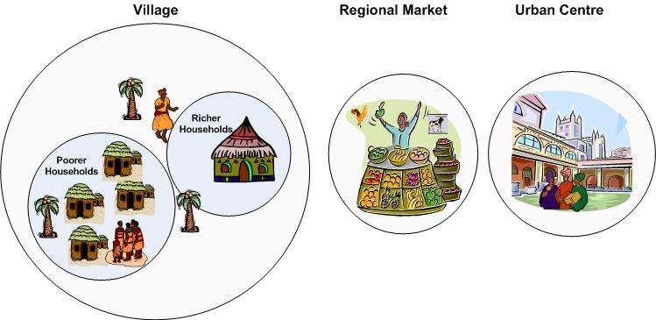
Labour, firewood, grass, charcoal
Grain, livestock, fish
Grain, livestock, fish

Grain
Household goods (salt, soap, oil, clothes)

Household goods (salt, soap, oil, clothes)

Higher value staple food
Labour/remittances

- You have been told that middle households in a particular livelihood zone run out of their own food about eight months after the harvest. They usually manage to produce and sell about three sacks of cotton. They also earn cash through agricultural labour, selling one or two goats, and selling firewood.

What prices should you check during a market visit which would be useful for finding out or cross checking:

- How much cash middle households are able to earn?

Answer:
The following price data would be useful:
- Price of cotton during month of sale
- Price of goats during month of sale
- Price of firewood during month of sale

Information on the going price for agricultural labour is important at different points of the year, but information on labour is best obtained from the source of demand, such as the local, better-off households who hire labour, or the source of supply, such as the poorer households themselves.

- How much food that cash could buy?

Answer:
To work out or cross check how much food a particular level of income could buy, you need to know the price of food over the five months they have to buy from the market.

- You are in a livelihood zone in which tobacco production is an important source of income for middle and better off households. All wealth groups buy maize at some point during the year.

What simple questions would you need to ask traders in order to understand what households are vulnerable to in terms of market change or disruption?

Answer:
For tobacco, you need to ask:
  - What is the main destination market for tobacco?
  - Does it pass through any intermediate markets?
You could also ask about how tobacco prices are fixed and about current price trends in the destination market.

For food, you need to ask:
- From where is food imported?
- Does it pass through any intermediate markets?

